|  |  |  |  |
| --- | --- | --- | --- |
| Name:  Teacher: | ____________________________________  ________________ | | Date:_________ |
|  | **Year 11 Mathematics**  /34  **Mini test**  **Topic – Percentages**  ***Full working out MUST be shown to get full marks for each question.*** | | |
| **Total Time:** | 10 minutes Non-Calculator  20 Minutes Calculator | Non-Calculator - /12  Calculator - /22 | |
| **Weighting:** | 5 % |
| **Equipment:** | To be provided by the student: Pens and Pencils, scientific calculator, A4 page of notes. | | |

|  |
| --- |
| **Question 1*****4 marks*** |

|  |  |
| --- | --- |
|  |  |

Use a strategy to solve the following

1. 21 x 42 b) 1368 ÷ 3 =

|  |
| --- |
| **Question 2** ***3 marks*** |

|  |  |
| --- | --- |
|  |  |

Fill in this table

|  |  |  |
| --- | --- | --- |
| Decimal | Percentage | Fraction |
|  | 22% |  |
| 0.124 |  |  |
|  |  | 3/20 |

|  |
| --- |
| **Question 3** ***2 marks*** |

|  |  |
| --- | --- |
|  |  |

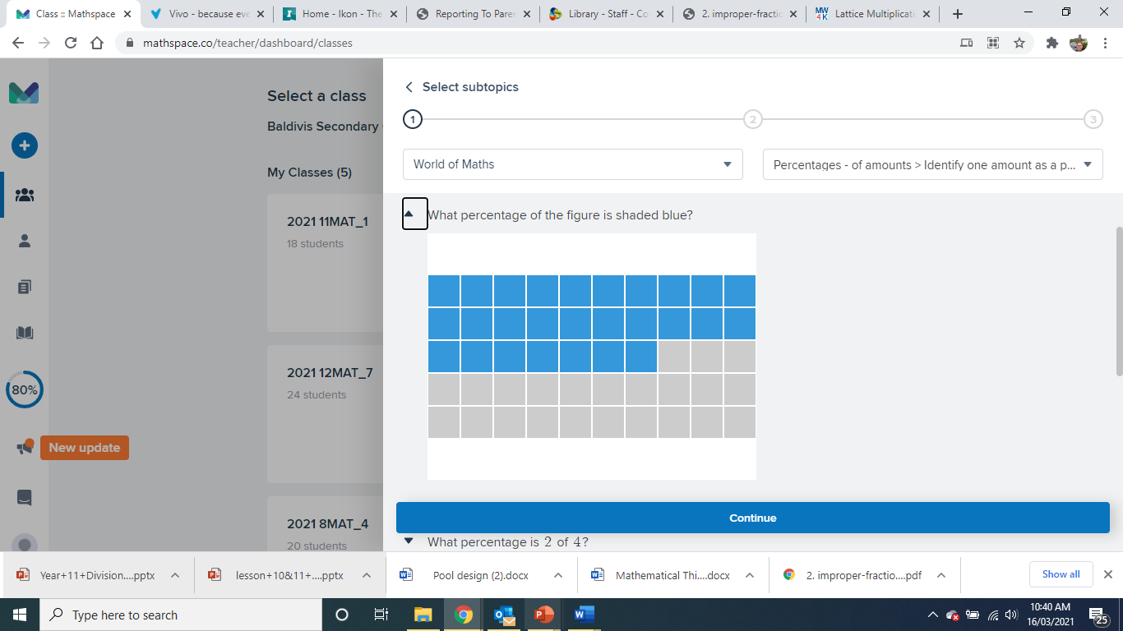

What percentage of this grid is shaded in?

|  |
| --- |
| **Question 4** ***3 marks*** |

Find 65% of 140 kg.

|  |  |  |  |
| --- | --- | --- | --- |
| Name:  Teacher: | ____________________________________  ________________ | | Date:_________ |
|  | **Year 11 Mathematics**  /22  **Mini test**  **Topic – Percentages**  ***Full working out MUST be shown to get full marks for each question.*** | | |
| **Total Time:** | 20 minutes Calculator |  | |
| **Weighting:** | 5 % |
| **Equipment:** | To be provided by the student: Pens and Pencils, scientific calculator, A4 page of notes. | | |

|  |
| --- |
| **Question 1** ***2,2 marks*** |

Decrease 712kg by 21% Increase 1245kg by 47.5%

|  |
| --- |
| **Question 2** ***3 marks*** |

There are 52800 fans at a football match between Collingwood and Carlton. 37% of the fans support Collingwood. How many fans at the match support Carlton?

|  |
| --- |
| **Question 3** ***3 marks*** |

Sasha takes a music exam. The table shows the result that Sasha can get for different percentages in her music exam. Sasha gets 62 out of 80 in the music exam.

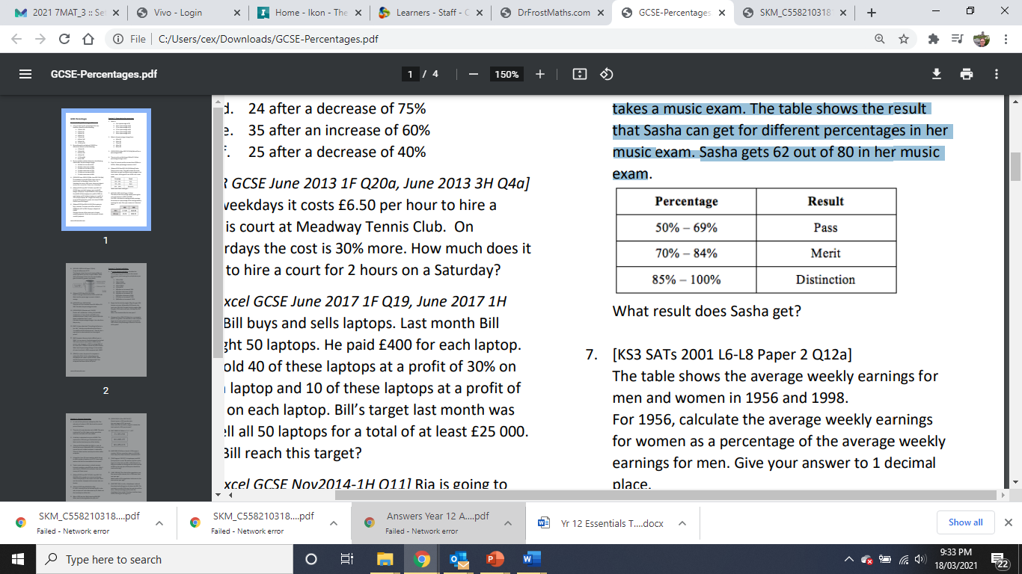What result does Sasha get?

|  |
| --- |
| **Question 4** ***3 marks*** |

The table gives information about the number of people voting for each party at an election. There are 52852 people who can vote.

The target was that 88% of people would vote.

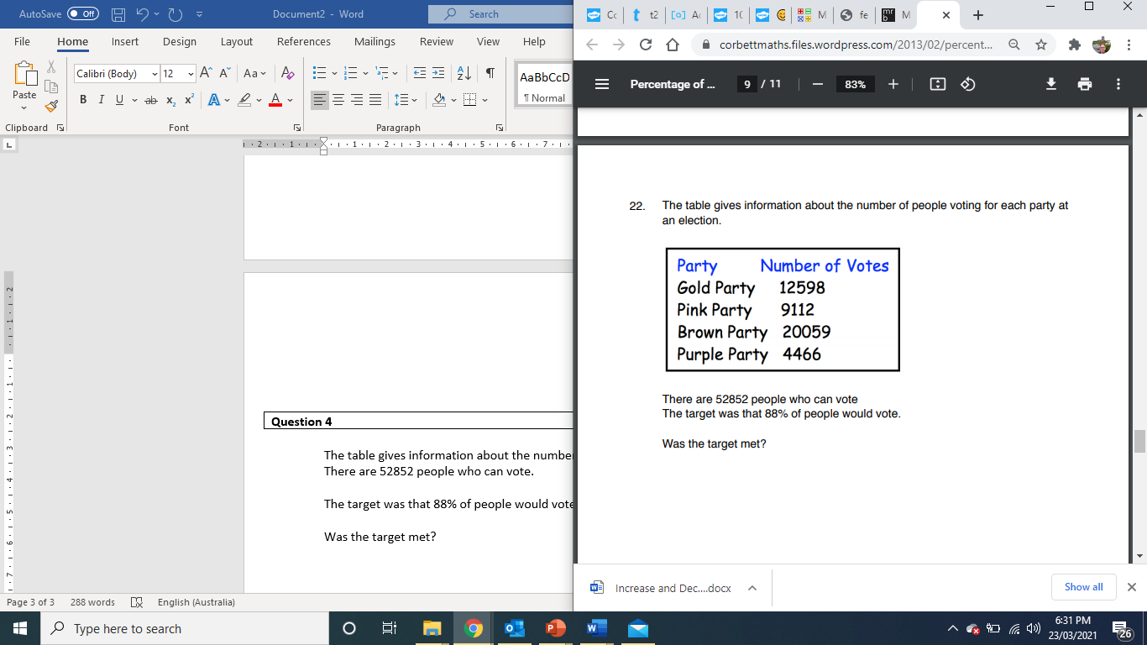Was the target met?

|  |
| --- |
| **Question 5** ***2 marks*** |

Sarah bought a TV for $250. Three years later she sold it for $180.

Calculate her percentage loss.

|  |
| --- |
| **Question 6** ***2,2 marks*** |

1. William’s salary is $84 000. His salary increases by 4%. Work out William’s new salary.
2. He then decides to spend 15% of his new salary to look at purchasing a car. How much is he willing to spend?

|  |
| --- |
| **Question 7** ***3 marks*** |

A fish tank sprung a leak and loses 45% of its water. There is now 363 litres of water in the fish tank. How much water was in the fish tank before the leak?

**End of Assessment**